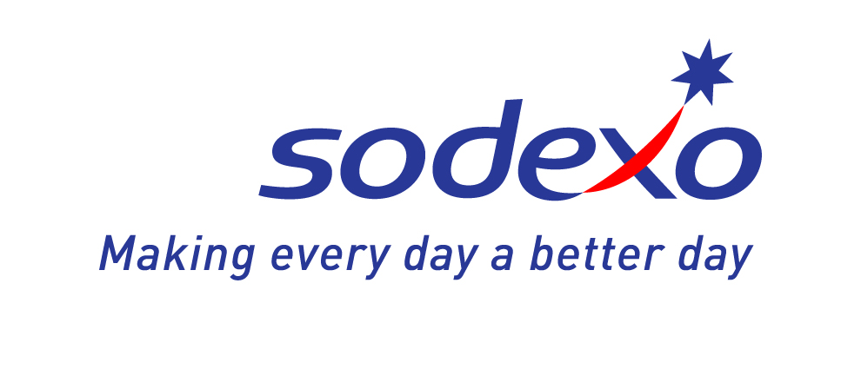

SUGAR SPICE AND
EVERYTHING NICE
We’ve Got the Holiday Season all Wrapped Up.
Featured Holiday Goodies:

Holiday Goodies: | Price List:
Holiday Pumpkin Loaf | Small Loaf: $6  Large Bundt Cake (Circular Loaf): $9
Cinnamon Swirl Loaf | Small Loaf: $6  Large Bundt Cake (Circular Loaf): $9
Holiday Banana Loaf | Small Loaf: $6  Large Bundt Cake (Circular Loaf): $9
Gingerbread Loaf | Small Loaf: $6  Large Bundt Cake (Circular Loaf): $9
Cranberry Orange Loaf | Small Loaf: $6  Large Bundt Cake (Circular Loaf): $9
Freshly Baked Cookies | 3 Pack: $3  6 Pack: $6
Holiday Rum Balls | 3 Pack: $3  6 Pack: $6

*Items available for the month of December!

Holiday Catering Specials:

 | Small | Medium | Large
 | 10-15 people | 15-20 people | 20-30 people
Seasonal Fresh Fruit Platter | $32 | $46 | $63
Seasonal Vegetable and Dip Platter | $23 | $33 | $43
Artisan Cheese and Cracker Platter | $40 | $50 | $60
Artisan Meat and Cheese Tray | $43 | $53 | $65
Holiday Dessert Tray | $30 | $55 | $80
Fresh Baked Cookie Platter | $17 | $23 | $28

*Please give 48 hours notice for catering orders.
*Payment for service is due on the date of your event and can be made with cash, Visa, or MasterCard.

Running behind? These amazing desserts could also be ordered for home and office parties.


